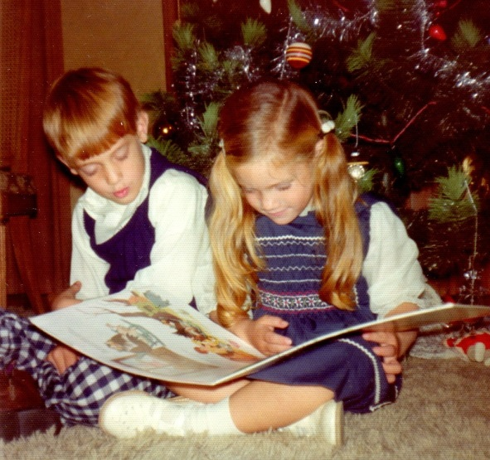

Brian Crenshaw and sister, Elaine Katherine Moore - 1974

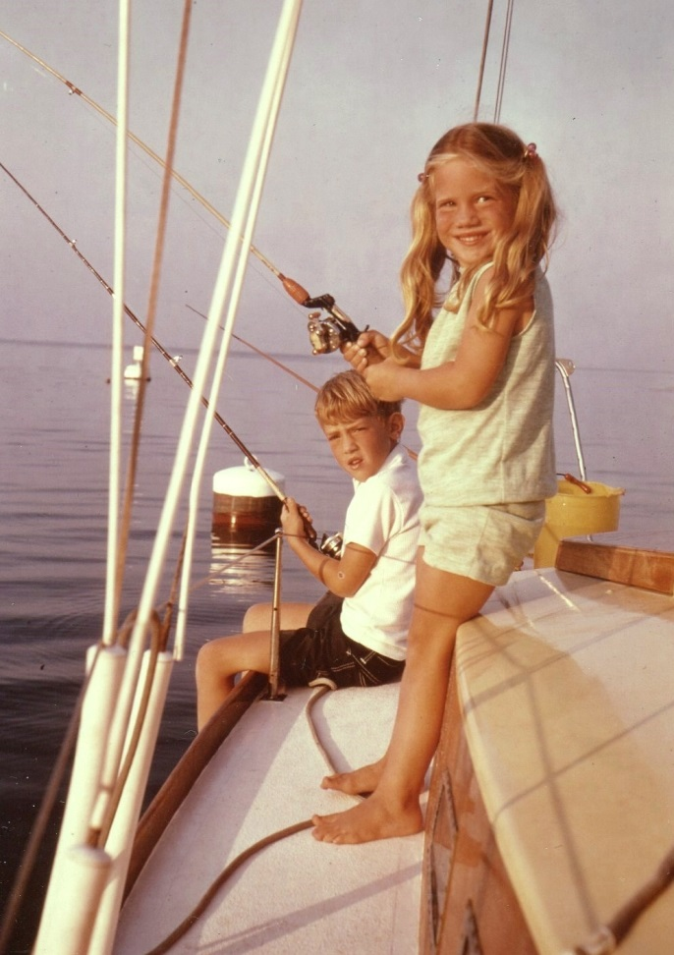

Elaine & Brian Moore fishing - 1975